Experiment No-05
Design of Sequential Logic Circuits using Verilog
1.1 Objectives
The main objectives of this experiment are summarized as:
- To understand the difference between combinational and sequential logic circuits, and the role of a clock signal and a reset in synchronous design.
- To design and simulate an edge-triggered D flip-flop in Verilog.
- To design and simulate a JK flip-flop in Verilog, and to verify its four operating modes: hold, reset, set, and toggle.
- To design and simulate a 4-bit synchronous up-counter built from edge-triggered sequential logic.
- To verify each design using the Incisive Enterprise Simulator (IES) / NCLaunch flow (compile, elaborate, simulate) and to analyze the results using SimVision waveforms.
Keywords- Sequential logic, D flip-flop, JK flip-flop, synchronous up-counter, asynchronous reset, dataflow/behavioral modeling, Cadence Incisive Enterprise Simulator (IES), NCLaunch, SimVision, test bench, waveform verification.
1.2 Theory
1.2.1 Combinational versus Sequential Logic
Unlike a combinational circuit, whose output depends only on the present inputs, a sequential logic circuit has memory: its output depends on both the present inputs and the circuit’s present state, which is stored in flip-flops and updated on clock edges. The flip-flop is the fundamental storage element of sequential design. A D (data) flip-flop simply captures the value present at its D input on the active clock edge and holds it until the next edge. A JK flip-flop is a more versatile storage element with two control inputs, J and K, that together select one of four operating modes on each clock edge: hold the current state, reset to 0, set to 1, or toggle to the opposite state. Counters are a classic application of flip-flops, where a chain of flip-flops updates its combined state by one count on every clock edge, wrapping back to zero once it reaches its maximum value. In this experiment, every design used an active-low asynchronous reset (rst = 0 forces the state to zero regardless of the clock).
1.2.2 The JK Flip-Flop Truth Table
The J and K inputs together select one of four operating modes on each active clock edge, summarized in Table-1.1.
J | K | Q (next) | Operation
0 | 0 | Q | Hold
0 | 1 | 0 | Reset
1 | 0 | 1 | Set
1 | 1 | ~Q | Toggle
Table-1.1. Operating modes of a JK flip-flop, selected by the J and K inputs on each active clock edge.
1.2.3 Cadence Incisive Enterprise Simulator (IES) and the NCLaunch Design Flow
As in the previous experiments, the Cadence Incisive Enterprise Simulator (IES), invoked through the NCLaunch graphical front end, was used to compile, elaborate, and simulate each design. For each of the three designs in this experiment, a lab/simulation directory was created, a cds.lib file mapping a worklib work library was created (selecting the “Don’t include any libraries (Verilog design)” option), the design and test bench source files were compiled with ncvlog, the test bench was elaborated with ncelab as the top-level module, and the resulting worklib snapshot was simulated, opening the Design Browser, Console, and Waveform windows of SimVision to inspect the $monitor output and the signal timing diagrams.

1.3 Hardware/Software Used for the Experiment
1. Cadence Incisive Enterprise Simulator (IES), invoked through NCLaunch
2. ncvlog (Verilog compiler), ncelab (elaborator), and the Incisive simulator (ncsim)
3. SimVision waveform viewer (Design Browser, Console, and Waveform windows)
4. gedit text editor, used to write the Verilog source and test bench files
5. Verilog HDL (IEEE 1364), with a simulation timescale of 1 ns / 1 ps
6. Linux workstation running the Cadence design environment

1.4 Experimental and Simulation Analysis
Three designs — a D flip-flop, a JK flip-flop, and a 4-bit synchronous up-counter, each with an active-low asynchronous reset — were each written in gedit, compiled and elaborated in NCLaunch, and simulated in SimVision, following the same compile (ncvlog) – elaborate (ncelab) – simulate flow described in the earlier experiments. The Verilog source code, test bench, NCLaunch compilation window, and SimVision console and waveform results for each design are presented in the following subsections.

1.4.1 D Flip-Flop (d_ff)
The D flip-flop was described behaviorally with an always block sensitive to posedge clk or negedge rst: whenever rst falls to 0 the output q is cleared asynchronously and immediately, independent of the clock; otherwise, on every rising edge of clk, q captures the value present at d. The Verilog source code is shown in Figure-1.1.

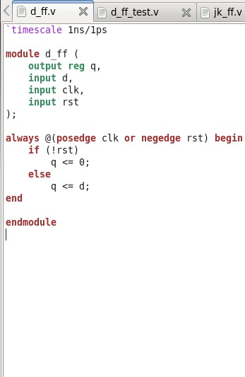 | 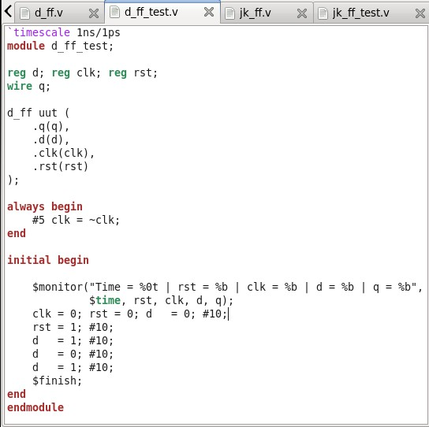
Figure-1.1. Verilog source code (d_ff.v) for the D flip-flop: an always @(posedge clk or negedge rst) block that asynchronously clears q when rst is low, and otherwise captures d into q on every rising clock edge. | Figure-1.2. Verilog test bench source code (d_ff_test.v), instantiating d_ff as uut, generating a 10 ns-period clock, releasing rst after 10 ns, and applying a sequence of d values every 10 ns.

The test bench (d_ff_test.v) instantiated d_ff as uut using named port connections, generated a clock with always #5 clk = ~clk, held rst low for the first 10 ns before releasing it, and then applied a sequence of d values (1, 0, 1) every 10 ns, while a $monitor statement printed rst, clk, d and q on every change. The test bench source code is shown in Figure-1.2.

The design compiled and elaborated without errors, with the worklib populated with the d_ff and d_ff_test modules and a Snapshots entry for worklib.d_ff_test:module, as shown in Figure-1.3.

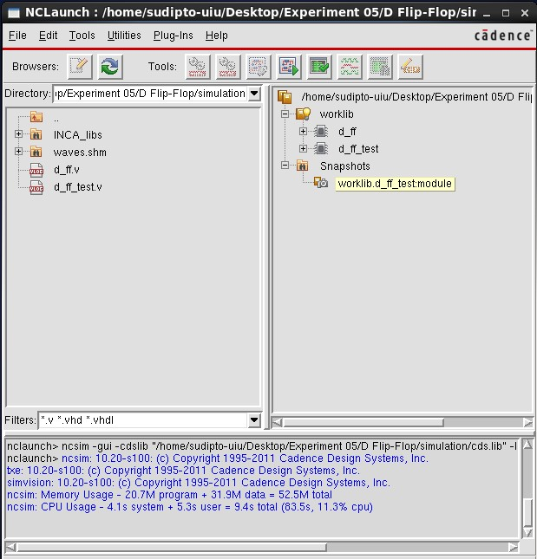 | 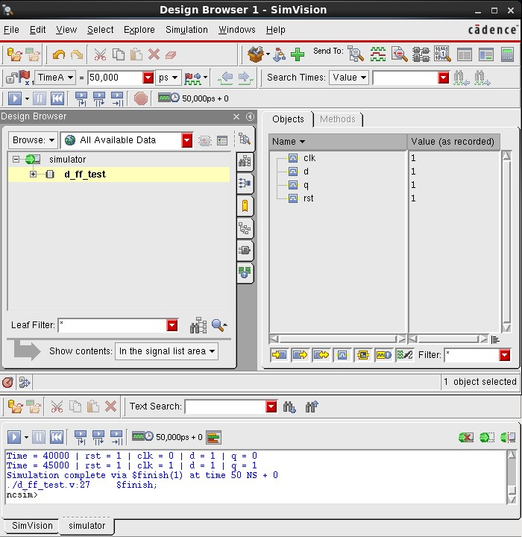
Figure-1.3. NCLaunch window for the D flip-flop, showing the worklib with the compiled d_ff and d_ff_test modules and the elaborated Snapshots entry, confirming successful compilation and elaboration. | Figure-1.4. SimVision Design Browser and Console windows for d_ff_test, showing the recorded signal values and $monitor output confirming that q correctly captures d on each rising clock edge, with the simulation completing via $finish at 50 ns.
The SimVision Console output confirms correct edge-triggered capture — for example, at Time = 40,000 ps, immediately before the next rising edge, rst = 1, clk = 0, d = 1 and q is still 0 from the previous cycle, and at Time = 45,000 ps, the rising edge of clk causes q to capture d, giving q = 1 with the simulation completing via $finish at 50 ns, as shown in Figure-1.4. The corresponding waveform, plotting clk, d, q and rst over the full 50 ns simulation, is shown in Figure-1.5.

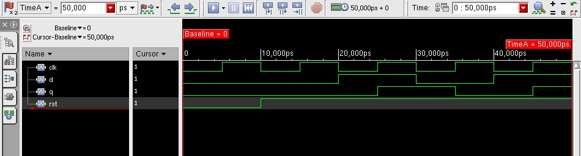
Figure-1.5. SimVision waveform for d_ff_test, showing clk, d, q and rst over the full 50 ns simulation, confirming that q follows d with a one-clock-edge delay once rst is released.

1.4.2 JK Flip-Flop (jk_ff)
The JK flip-flop was described behaviorally with a case statement on the concatenation {j, k} inside an always @(posedge clk or negedge rst) block, implementing the four modes of Table-1.1 (hold, reset, set, toggle), together with a continuous assignment, assign qbar = ~q, for the complementary output. The Verilog source code is shown in Figure-1.6.

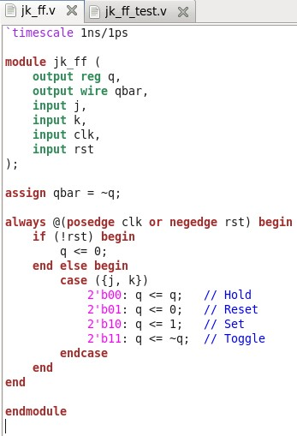 | 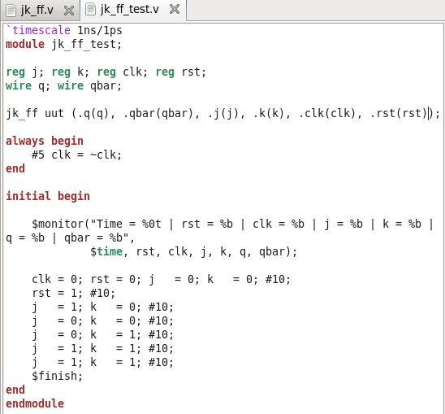
Figure-1.6. Verilog source code (jk_ff.v) for the JK flip-flop: a case ({j, k}) statement inside an always @(posedge clk or negedge rst) block implementing hold, reset, set and toggle, with assign qbar = ~q. | Figure-1.7. Verilog test bench source code (jk_ff_test.v), instantiating jk_ff as uut and stepping through Set, Hold, Reset, and Toggle (applied twice) after releasing rst, each mode held for 10 ns.

The test bench (jk_ff_test.v) instantiated jk_ff as uut using named port connections, generated a 10 ns-period clock, released rst after 10 ns, and then stepped through Set (j=1,k=0), Hold (j=0,k=0), Reset (j=0,k=1), and Toggle (j=1,k=1) applied twice in succession, each held for 10 ns, while a $monitor statement printed rst, clk, j, k, q and qbar on every change. The test bench source code is shown in Figure-1.7.

The design compiled and elaborated without errors, with the worklib populated with the jk_ff and jk_ff_test modules and a Snapshots entry for worklib.jk_ff_test:module, as shown in Figure-1.8.

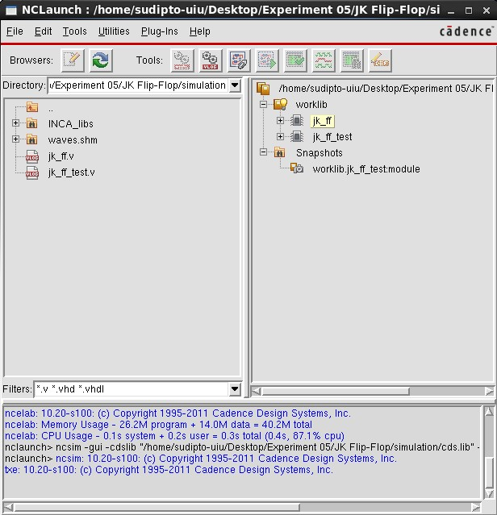 | 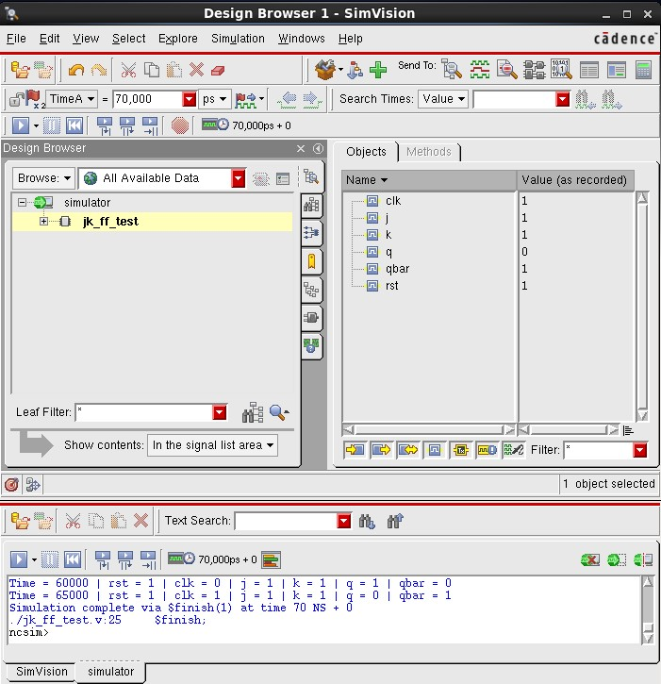
Figure-1.8. NCLaunch window for the JK flip-flop, showing the worklib with the compiled jk_ff and jk_ff_test modules and the elaborated Snapshots entry, confirming successful compilation and elaboration. | Figure-1.9. SimVision Design Browser and Console windows for jk_ff_test, showing the recorded signal values and $monitor output confirming the Set, Hold, Reset and Toggle modes, with the simulation completing via $finish at 70 ns.

The SimVision Console output confirms all four modes — at Time = 60,000 ps, j = k = 1 (Toggle) gives q = 1, qbar = 0 (the first toggle, from the q = 0 left by the preceding Reset step), and at Time = 65,000 ps, the second Toggle step flips the state again, giving q = 0, qbar = 1 — with the simulation completing via $finish at 70 ns, as shown in Figure-1.9. The corresponding waveform, plotting clk, j, k, q, qbar and rst over the full 70 ns simulation, is shown in Figure-1.10.

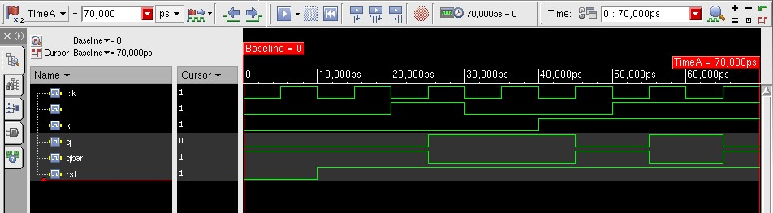
Figure-1.10. SimVision waveform for jk_ff_test, showing clk, j, k, q, qbar and rst over the full 70 ns simulation, confirming all four JK flip-flop operating modes in sequence.

1.4.3 4-bit Counter (counter_4bit)
The 4-bit counter was described behaviorally with an always @(posedge clk or negedge rst) block: whenever rst falls to 0, count is asynchronously cleared to 4’b0000; otherwise, on every rising edge of clk, count is incremented by 1, so that it counts 0000, 0001, …, 1111 and then wraps back to 0000. The Verilog source code is shown in Figure-1.11.

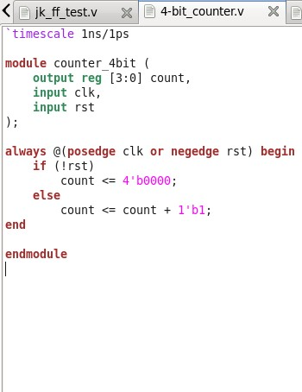 | 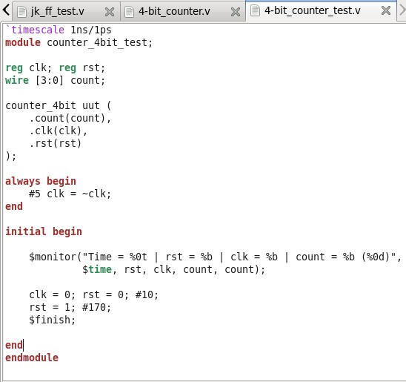
Figure-1.11. Verilog source code (counter_4bit.v) for the 4-bit synchronous up-counter: an always @(posedge clk or negedge rst) block that asynchronously clears count when rst is low, and otherwise increments count by 1 on every rising clock edge. | Figure-1.12. Verilog test bench source code (counter_4bit_test.v), instantiating counter_4bit as uut, releasing rst after 10 ns, and running for a further 170 ns so that the full 0000-to-1111 count sequence and its wrap-around are exercised.

The test bench (counter_4bit_test.v) instantiated counter_4bit as uut, generated a 10 ns-period clock, held rst low for the first 10 ns, then released it and ran for a further 170 ns — long enough for all sixteen counts (0000 through 1111) plus the wrap back to 0000 to occur — while a $monitor statement printed rst, clk and count, in both binary and decimal, on every change. The test bench source code is shown in Figure-1.12.

The design compiled and elaborated without errors, with the worklib populated with the counter_4bit and counter_4bit_test modules and a Snapshots entry for worklib.counter_4bit_test:module, as shown in Figure-1.13.

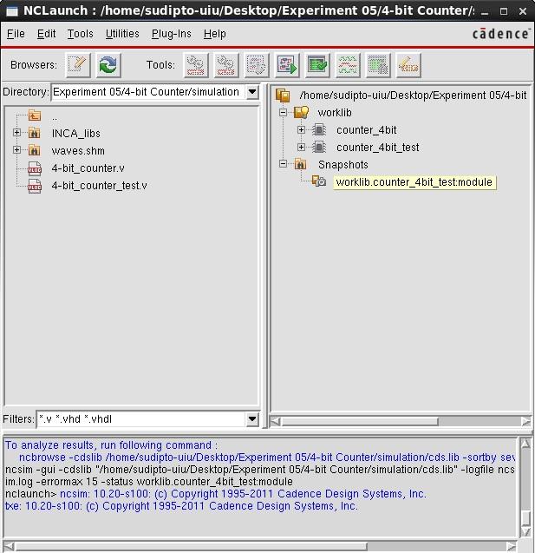 | 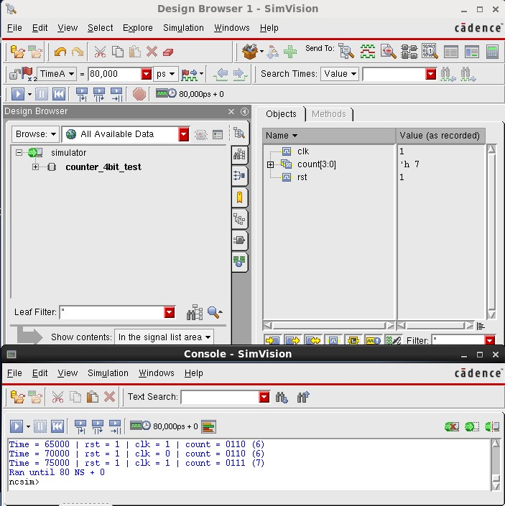
Figure-1.13. NCLaunch window for the 4-bit counter, showing the worklib with the compiled counter_4bit and counter_4bit_test modules and the elaborated Snapshots entry, confirming successful compilation and elaboration. | Figure-1.14. SimVision Design Browser and Console windows for counter_4bit_test, showing the recorded signal values and $monitor output confirming that count increments by one on every rising clock edge.
The SimVision Console output confirms the counter incrementing by one on every rising clock edge — for example, at Time = 65,000 ps, count = 0110 (6), and at Time = 75,000 ps, count = 0111 (7) — as shown in Figure-1.14. The captured waveform, shown in Figure-1.15, plots clk, count[3:0] (with the individual bits count[3] to count[0] also expanded) and rst, but only over the first 80 ns of the 180 ns simulation, showing count advancing correctly from 0000 up to 0111 (7); the full wrap-around from 1111 back to 0000, which the 170 ns run time was specifically chosen to capture, occurs later in the simulation (around t = 170 ns) and falls outside the time range shown in this particular waveform screenshot.

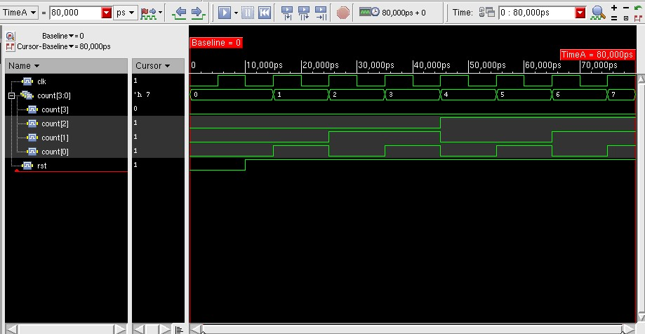
Figure-1.15. SimVision waveform for counter_4bit_test, showing clk, count[3:0] (with individual bits expanded) and rst over the first 80 ns of the simulation, confirming correct counting from 0000 up to 0111.
1.5 Discussion
The SimVision waveform and $monitor output for jk_ff_test confirmed all four operating modes selected by {j, k} on each active clock edge: with j = 1, k = 0 the flip-flop entered Set mode and q was driven to 1; with j = 0, k = 0 it entered Hold mode and q remained unchanged from its previous value; with j = 0, k = 1 it entered Reset mode and q was driven to 0; and with j = 1, k = 1 it entered Toggle mode, observed twice in succession, q flipped from 0 to 1 on the first toggle (Time = 50,000 ps) and from 1 to 0 on the second toggle (Time = 65,000 ps), confirming that qbar, the complement of q, also updated correctly on every edge. For the 4-bit counter, the test bench was written to run for 170 ns after reset release specifically so that all sixteen counts, 0000 through 1111, plus the wrap back to 0000, would occur within the simulated window; the captured waveform screenshot, however, spans only the first 80 ns of that run and shows count advancing correctly from 0000 up to 0111 (7), rather than the full wrap-around, so the 1111-to-0000 transition itself was not directly captured on the waveform image analyzed here.
1.6 Conclusion
In this experiment, a D flip-flop, a JK flip-flop, and a 4-bit synchronous up-counter, each with an active-low asynchronous reset, were designed in Verilog HDL and verified using the Cadence Incisive Enterprise Simulator (IES) through the NCLaunch design flow. All three designs were described behaviorally with always @(posedge clk or negedge rst) blocks, using an if statement for the D flip-flop and counter and a case statement on {j, k} for the JK flip-flop’s four operating modes. Each design was compiled with ncvlog, elaborated with ncelab, and simulated, and the resulting SimVision waveforms and $monitor console output confirmed edge-triggered D-capture, all four JK flip-flop modes (hold, reset, set, toggle), and correct up-counting for the portion of the count sequence captured on the waveform. This experiment provided practical, hands-on experience with sequential (clocked) Verilog modeling, asynchronous reset behaviour, and reading SimVision waveforms for clocked designs, which forms the basis for more complex synchronous digital design in subsequent experiments.

